**Test Cases:**

1. If user is not logged in, and if user navigates to update page, it redirects to login page.

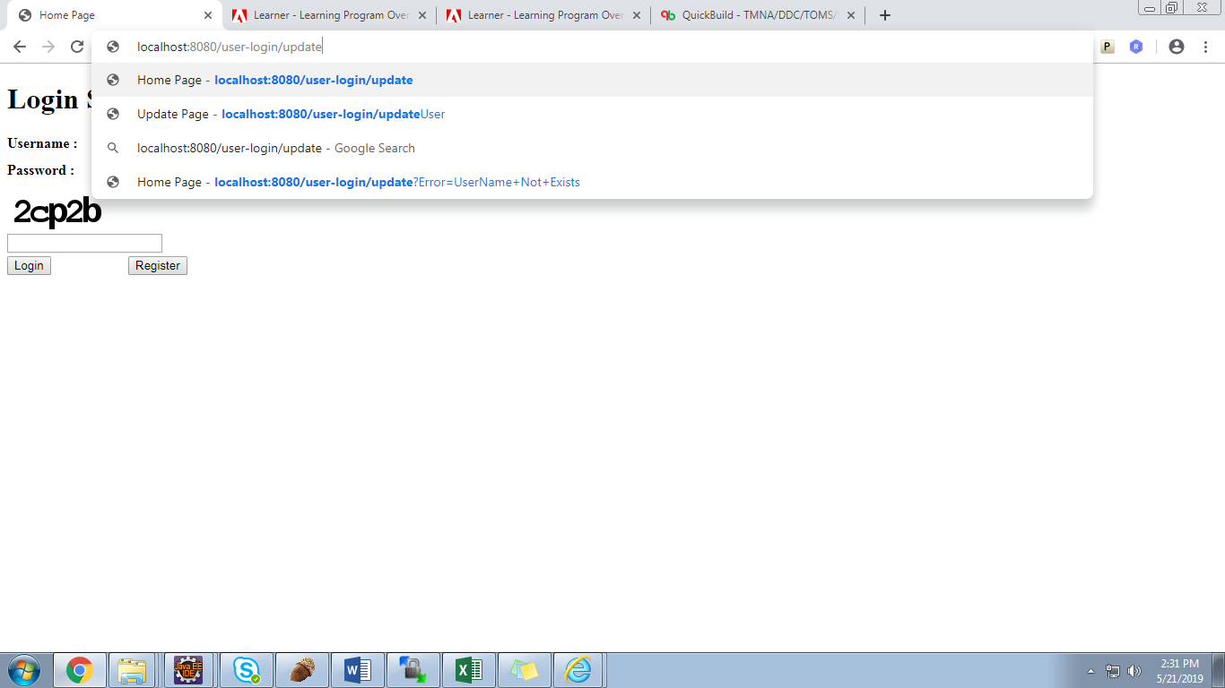

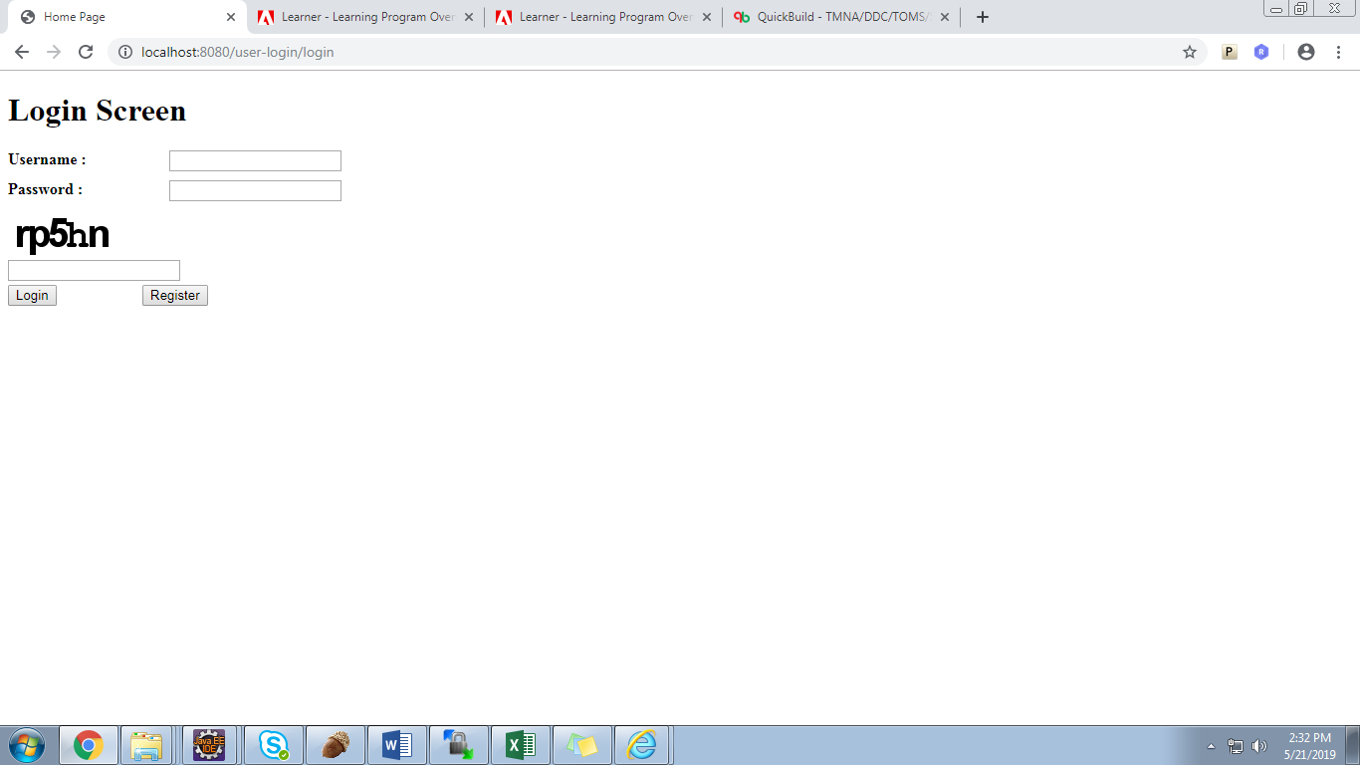

1. If the user types in wrong user name and password, it will say “User name or password is incorrect”.

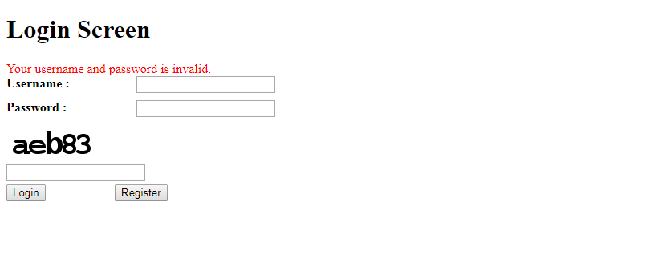

1. If user types in wrong captcha, it will say that Captcha is wrong.

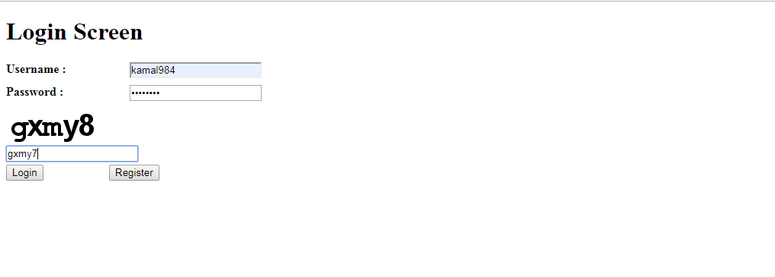

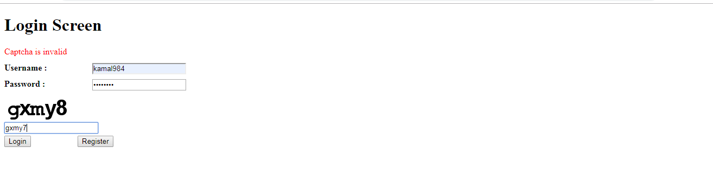

1. If Username, password, captcha is correct, user will land in update page.

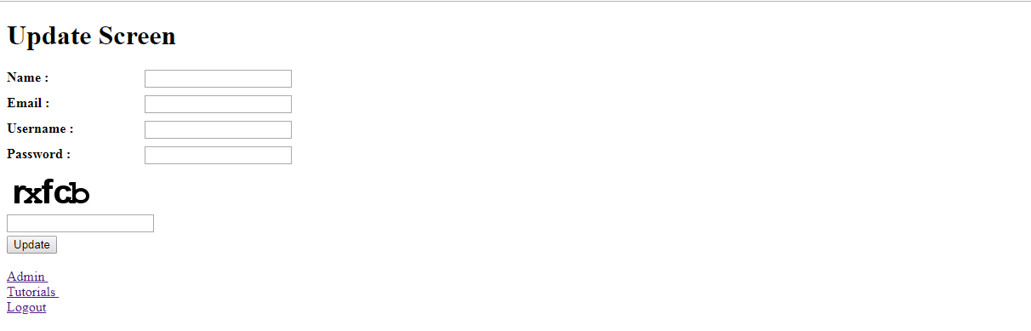

1. If username is correct, users will be able to update their information.

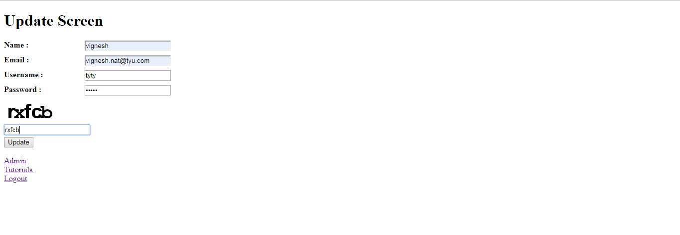

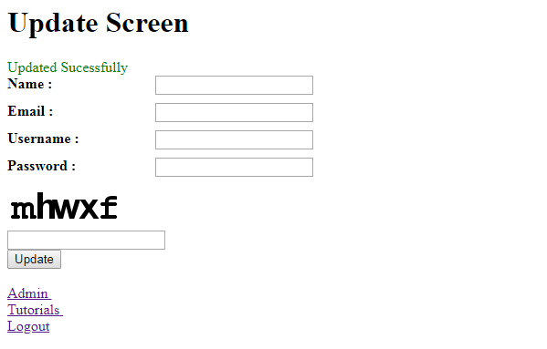

1. If username is not valid, it will show error.

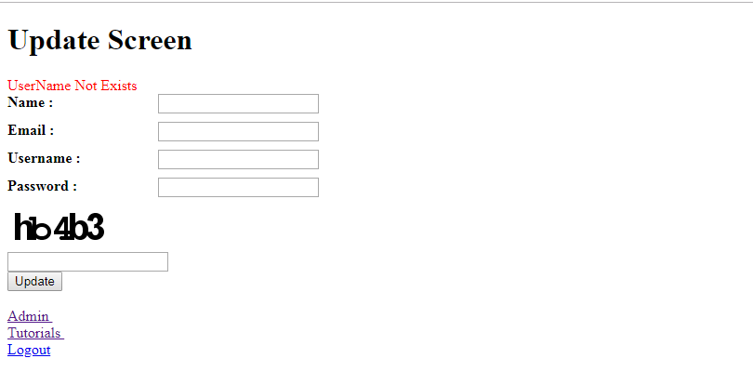

1. If capchta is invalid, it will show error:

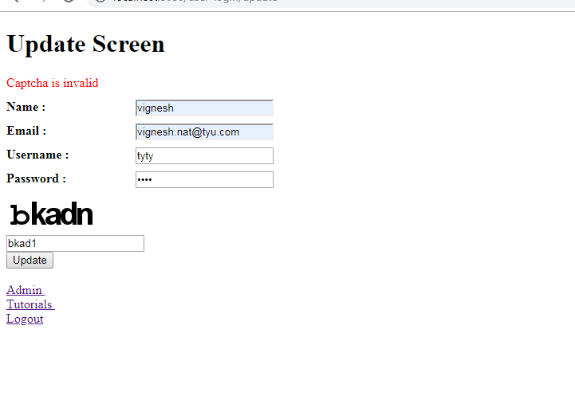

1. Only admin users can access admin page, else error will be showed.

For Admin, dummy page will be displayed:

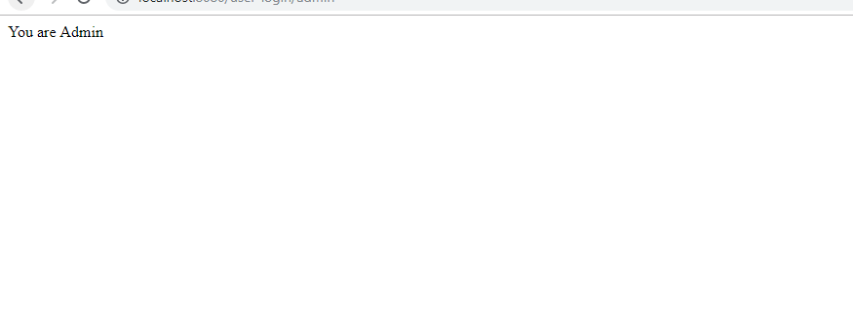

For Normal users, error will be displayed.

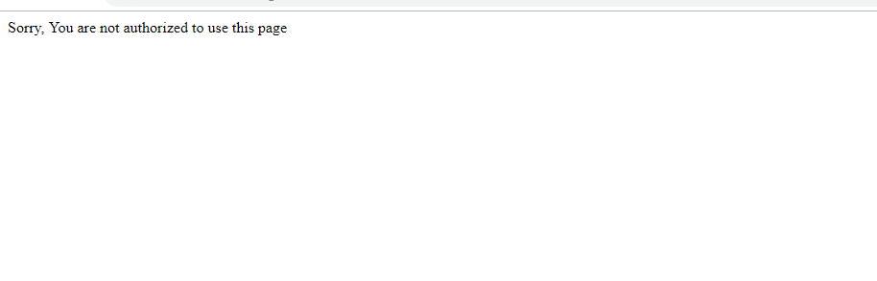

1. Dummy tutorials page will be displayed for users.

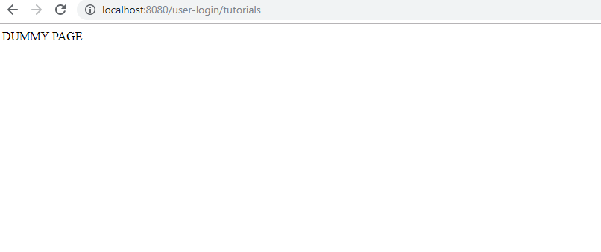

1. Users will be able to logout of their sessions, once they logout login page will be shown:

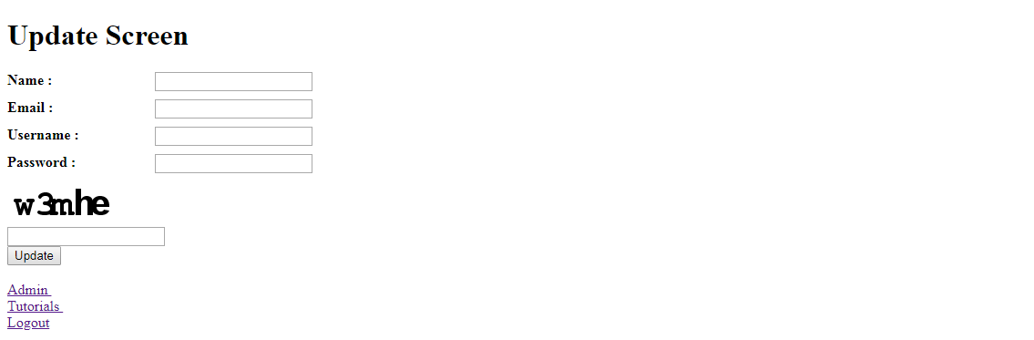

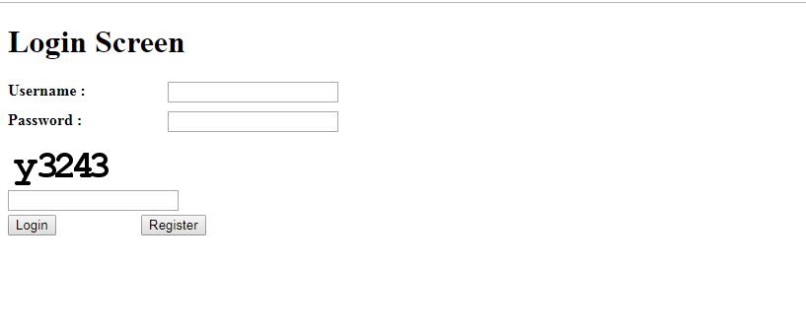

1. New Users will be able to register.

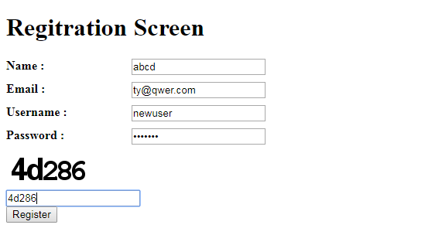

Once they register, they will be taken to update page.

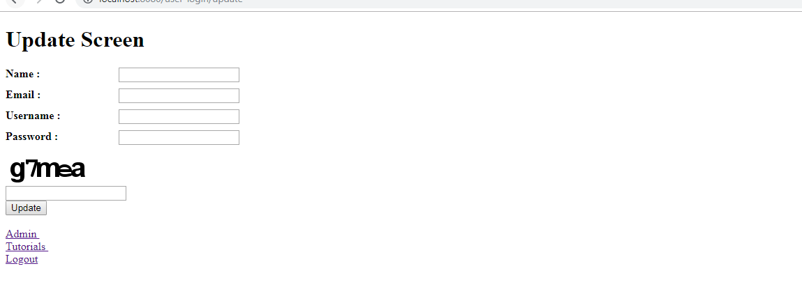

1. If user already exists, error will be shown in register page.

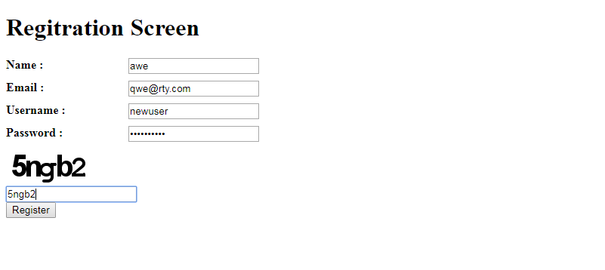

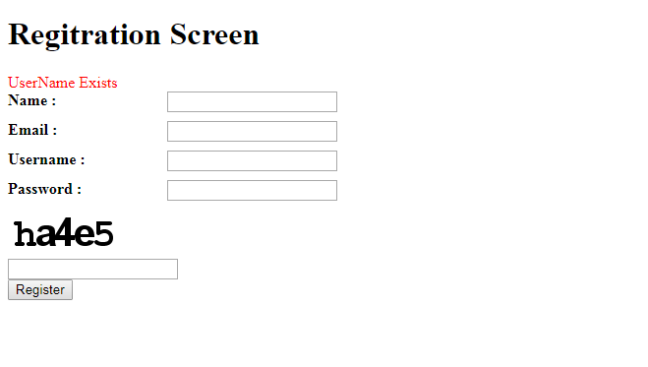

**Evaluation criteria:**

S.no

Activity

Check

Associate Remark

1

Create a Maven project

Done

2

Use POM.xml to manage dependencies

Done

3

Deployment Descriptor is created and configured to open default page of the spring mvc applicaton

Done

4

Dispatcher Servlet is created and configured as per requirements

Done

5

Controllers are created in repsectve package (com.something.controller)

Done

6

POJO classes are created where required in respectve package (com.something.pojo)

Done

7

Entty classes are created where required in respectve package (com.something.entty) for different groups of users

Done

8

Service classes are created where required in respectve package (com.something.service)

Done

9

DAO classes are created where required in respectve package (com.something.dao)

Done

10

View is created for user registraton

Done

11

View is created for user login

Done

12

View is created for account update

Done

13

If the user is not logged in, account update page is redirectng the user to login page; with line saying - login to update your account

Done

14

If the user is logged in, he/she can logout to come out of the secure session

Done

15

Admin (Page with dummy message about admin) page is visible and accessible only to the logged-in user who is super-admin

Done

16

Spring Security is used to implement user roles (guest user, logged-in user, super user)

Done

17

CAPTCHA image is being created by class in utl package (com.something.utl) and sent with response to view

Done

18

Have used Spring logging to dump the logs

Done

19

Have used Spring Validatons for validatng the user registraton informaton in respectve package (com.something.validaton)

Done

20

Have used Spring Exceptons to manage exceptons in respectve package (com.something.excepton)

Done

**Code Zip file (Maven Project):**

